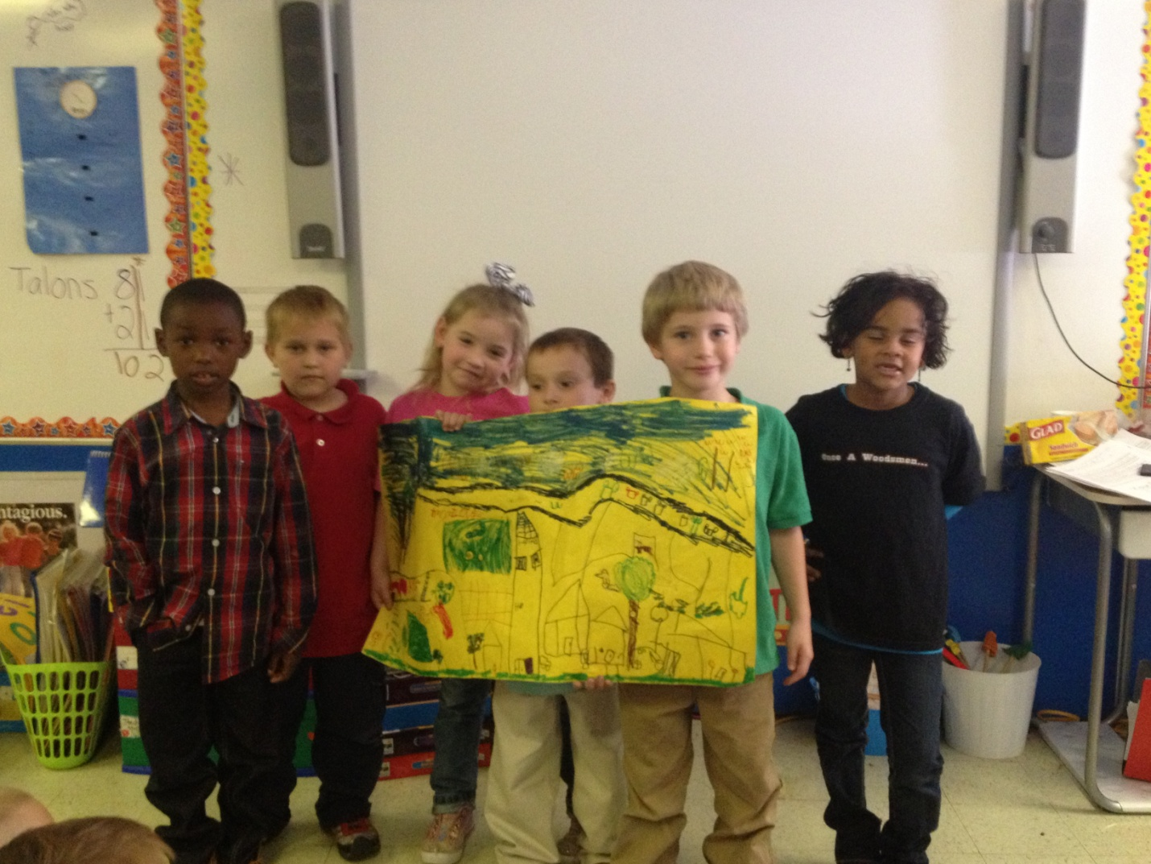

This group created the Suburban area. We learned about all different areas and each group had to recreate what they had learned about different communities.
*Smiley faces are students who cannot be pictured online.
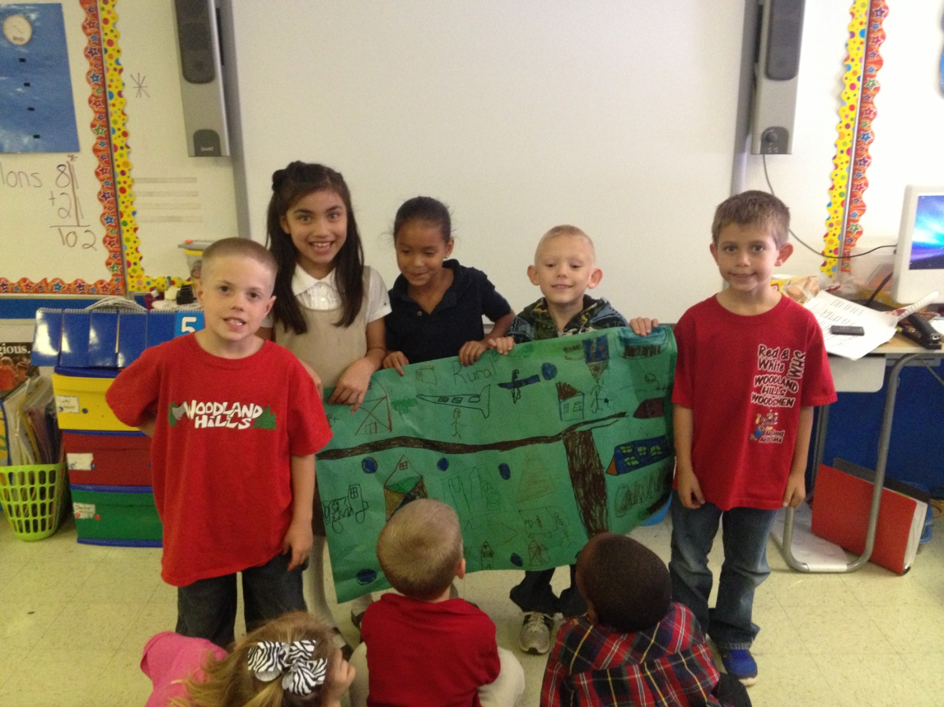

This group created the Rural area. We learned about all different areas and each group had to recreate what they had learned about different communities.
*Smiley faces are students who cannot be pictured online.

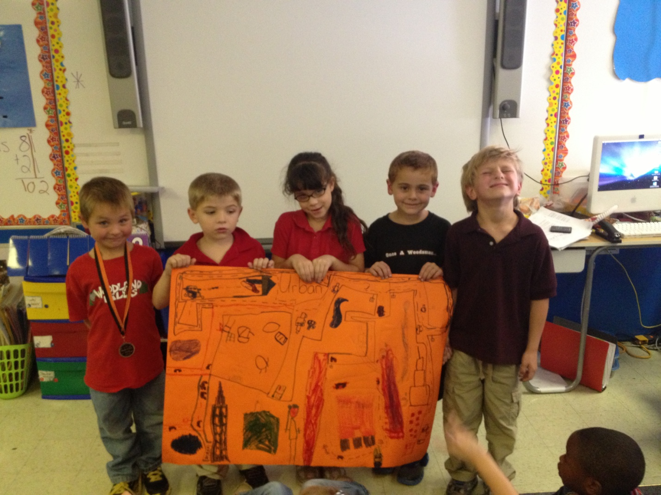

This group created the Urban area. We learned about all different areas and each group had to recreate what they had learned about different communities.
*Smiley faces are students who cannot be pictured online.

